RESERVATION FORM

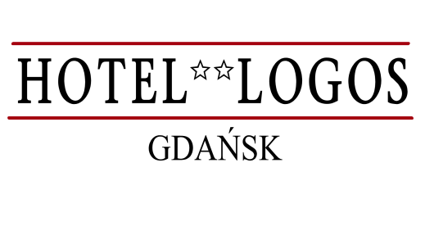

tel. +48 58 341 91 16, fax +48 58 341 55 87,
e-mail: rezerwacje@hotellogos-gdansk.pl

IV BALTIC BIOGAS FORUM

GDAŃSK, 11-12.09.2014

I would like to ask for a reservation in HOTEL LOGOS according to the details given below:

First name: .................................. Surname: ............................................

Period of stay: from _ _/_ _/_ _ until _ _/_ _/_ _

Number of nights: ……..

Type of the room:

SGL room 220 PLN/ night DBL room 260 PLN/ night

The prices presented above include breakfast and VAT

Form of reservation guarantee:

credit card guarantee

Credit card name....................................... No ............................ Valid until…………..

Form of payment (please note that the hotel takes also guarantee for extra services at the check in):

cash – on the day of departure
credit card – on the day of departure

……………………… ……………………………
City, date Signature

