**X.X Guidelines for the authors   
of HYDROFORUM 2024 Conference Proceedings**

|  |  |
| --- | --- |
| **Eminent Researcher**  University of Everything PO Box 20969, Penstock City, Investland e-mail: eminent.researcher@univ.inv | **Proud Manufacturer, Superb Designer**  Best Turbine Company  Hydropower street 21, Turbine City, Hydroland e-mail: proud.manufacturer@hydro.hld; superb.designer@hydro.hld |

**General**

The conference contributions will be published in Conference Proceedings as mini-article and extended abstracts. The Proceedings will be disseminated among conference delegates in electronic and printed version directly before the debate.

The authors are asked to submit their contributions in electronic version till September 8th this year. The contributions should be prepared according to the recommendations presented in this document. The Organising Committee cannot guarantee printed publication of contributions submitted after September 15th.

The division between the extended abstracts and mini-articles is of stipulatory nature. Formally, the abstract volume – including possible illustrations – should not exceed 2 page of A4 format. From the substantative point of view, the abstract should give the reader general orientation in the contribution scope and enable understanding of its main theses. The volume of a mini-article may reach up to 4 pages of A4 format. Exceeding this limit should be agreed with the Organising Committee. Depending on the contribution character, the mini-article is expected additionally explaining the author’s line of thought and/or providing most important information representing the contribution subject.

Please, balance appropriately between the technical and possible commercial contents. Following the procedure explained in the Registration Form, a footnote “Commercial contents comprised” will be added by the Organising Committee if relevant. In view of our experience, such a procedure will only raise transparency of our approach and serve well the authors.

**Editorial recommendations**

The authors are invited to use this template and the MS Word or compatible editor when preparing your text. It is recommended to keep the document - including illustrations if any – within the limit of 2 A4 sheets with 20 mm margins at all sides. Slight deviations from this rule are allowable. The *Times New Roman* font is to be used throughout the whole document. Each paragraph - except the paper title - is to be followed by a 6 point pica spacing.

The abstract should commence with the title printed with bold letters of 16 point height, separated with 16-point spacing from the top margin and the author (s) data. You are expected to leave a 15 mm spacing at the beginning of the line in order to enable us writing in the contribution identifier (session number and the consecutive number of the contribution). The names of authors should be printed using bold font of 11 point height in one or two columns. The names of authors should be followed by their affiliation printed with a font of 10 point height. Please, use one column (table cell) for co-authors with the same affiliation. In case of joint affiliation of all the authors it is recommended to merge the relevant table cells.

The e-mail address of the corresponding author is to be written below his affiliation. Providing the same information on other authors is optional Providing full postal addresses is also optional.

After leaving one empty line the abstract text is to be written down using the same font with justification to both sides. The text may be divided into sections with headings written down in a bold font of 11 points height. 6 point spacing below the section heading is to be applied. The same style is to be used for headings of "References" and "Authors" sections comprising bibliographical data and biographic notes. Leaving a 6 point spacing above both these headings is recommended. Please, use 9 point font for both sections. In case of min-articles it is recommended to use the section heading numeration.

Reference to bibliographical items is made in the text using relevant numbers placed in square brackets [1]. References should be numbered according to the order in which they appear in the main text. The titles of cited unpublished studies should be translated into the language of the main text, marking the language of the original in brackets, e.g. (in German). The same should be done in the case of publications printed in an alphabet other than Latin or Cyrillic. In the case of citing printed publications in Cyrillic, the use of the original alphabet or transcription is the author’s choice.

Figures, tables and equations, if any, may extend over the single or double column width. Please, use the section divisions appropriately when preparing your abstract by means of the MS Word editor. The figure and table captions, if any, shall be written using a bold font of 9 point height, commencing with "Fig." or "Table" (Fig.1). Formulas should be written down in the middle, between column edges. Wide column format may be applied for some long formulas. Numbering, if any, should be adjusted to the right column edge.

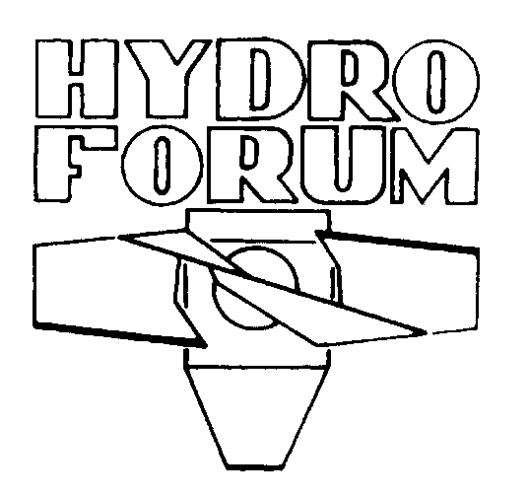

**Fig.1 Historical logo of HYDROFORUM Conferences**

**Final remarks**

All the abstracts will be subject to a swift peer-view by the Organising Committee editorial team which keeps the right to introduce obvious technical corrections, to issue recommendations for the author(s) and even to rejection the text in some extreme cases.

The HYDROFORUM 2024 Proceedings will be published by the Publishing House of the Szewalski Institute of Fluid-Flow Machinery (IMP PAN) and provided with an ISBN number. In addition, publication of your presentation in form of a pdf file available from the website of the Polish Hydropower Association is planned. Authors will have 2 weeks after the Conference for including amendments or reporting reservations against making their presentation publicly available.

Authors of selected contributions will be proposed to submit the full-length papers for publication in *Energetyka Wodna* quarterly. The invitations to submit a post-conference full-paper to a special issue of Technical Transactions of Cracow University of Technology or *Transactions of the IFFM* will be consulted with the Scientific Committee and submissions will be subject to a standard peer-viewing process. Please note that publishing the special issue will depend on the number of proposed submissions (at least 6).

**References**

1. **Punys P., Söderberg C., Söderlund T., Wänn A**.: *Strategic Study for the Development of Small Hydro Power (SHP) in the European Union*, ESHA/SERO/LHA, Brussels, 2007
2. **Boschi A**.: *The EIB’s approach to financing hydro projects.* A paper delivered to the HYDRO 2009   
   Conference, Lyon, 26-28 October 2009, Abstract 1.0
3. **Bykov A., Bykov Yu., Dedkov V., Steller J**.: *Numerical modelling of flow in the draft tube of a hydraulic turbine,* Cieplne Maszyny Przepływowe, Turbomachinery, 2002, No.122, pp.11-18

**Authors**

**Eminent Researcher,** DSc,graduated in 1990 in mechanical engineering from the University of Technology in the European Union and worked for a number of companies before joining the R&D department of the University of Everything, which awarded him a PhD degree in 2006 and the DSc degree in 2014. He has been involved in development of new turbine designs in the EU and worldwide.

**Proud Manufacturer**, MSc, graduated in hydraulics from the University of xxxx. Cvcvcvcvcvcvcvcvcv cvcvcvcvcvcvc vcvcvcvcvcc.

**Superb Designer**, MSc, graduated in hydraulics from the University of xxxx. Cvcvcvcvcvcvcvcvcv cvcvcvcvcvcvc vcvcvcvcvcc.