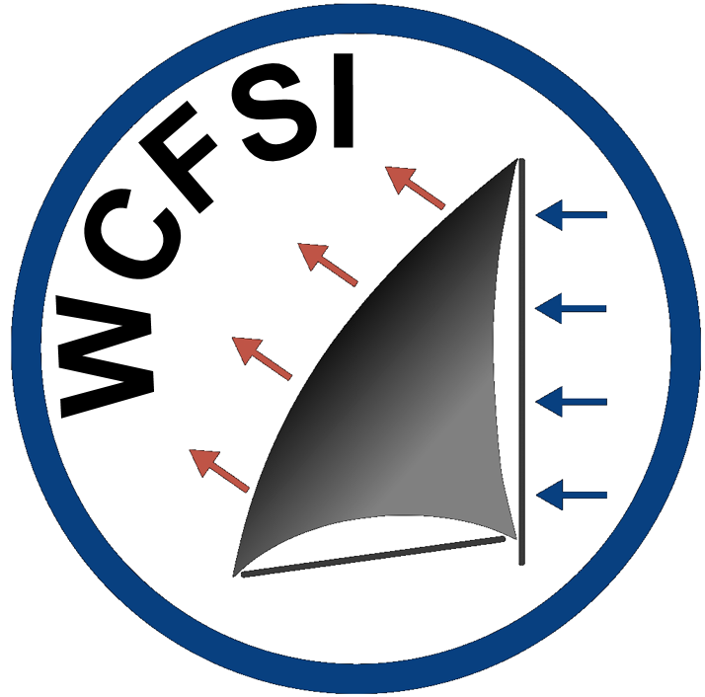
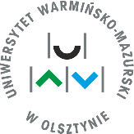
13th WDZYDZEANUM CONFERENCE
ON
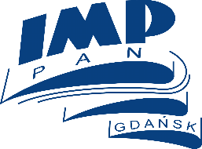
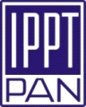FLUID – SOLID INTERACTION
WDZYDZE KISZEWSKIE, POLAND, 31.08-04.09.2025

THE HONORARY PATRON: PROF. MARCIN LACKOWSKI, DIRECTOR OF IMP PAN

Basic information

Conference is planned from 31.08.2025 to 04.09.2025 in Villa Marzenie: (Holiday Houses Helena – Danuta – Gabriela, https://www.helena.kaszuby.pl, 9-11 Róży Ostrowskiej Street, 83-406 Wdzydze Kiszewskie, tel.: +58 686 13 08, mobile: +48 602 242 512, email: helenadw@wp.pl). In addition, FSI laboratories on sailboats start in „U Grzegorza” Marina (Wdzydze Kiszewskie, 9 Stolema St.). This event is organized by three entities: Energy Conversion Department at the Institute of Fluid Flow Machinery of the Polish Academy of Sciences (IMP PAN) in Gdańsk, the Institute of Fundamental Technological Research of the Polish Academy of Sciences (IFTR PAS) in Warsaw and University of Warmia and Mazury in Olsztyn (UWM) . To participate in the 13th Wdzydzeanum Conference, please fill and send registration form and abstract to wdzydzeanum@imp.gda.pl and make bank transfer payment according to the table below. Price includes full costs of accommodation, food and FSI laboratories.

Registration deadline  – fill and send Registration Form | 12.07.2025
Abstract submission deadline | 18.07.2025
Payment deadline  - payments should be made on bank account of the Polish Academy of Sciences in Gdańsk:  bank BGK in Gdańsk, PL 28 1130 1121 0006 5498 9520 0011, SWIFT: GOSKPLPW  Title: WDZYDZEANUM + name and surname of participant | 12.08.2025

Conference profile
This event is organized to integrate the community of researchers and inventors focused on modelling, testing and utilization of phenomena occurring at the boundary between fluid and solid. That includes, but is not limited to any kind of combustion, renewable energy generation, porous media flow, catalytic combustion, filters application, fuel cells, turbines cooling, profitability studies and energy storage technologies. Entrepreneurs and power sector employees are warmly welcomed. Their feedback will be an important input into the discussion about the scientific work commercialization. All presentations will be given in English.

REGISTRATION FORM
OF CONFERENCE: 13th WDZYDZEANUM CONFERENCE ON FLUID – SOLID INTERACTION
WDZYDZE KISZEWSKIE, 31.08.-04.09.2025
Organized by:
Energy Conversion Department IMP PAN, IFTR PAS and UWM in Olsztyn
Name and surname:
……………………………………..
Title, scientific title and work position:
………………………………………
Correspondence address:
…………………………………………….
…………………………………………….
…………………………………………….
…………………………………………….
Phone and email:
……………………………………….
Title of the presentation:
………………………………………………………………………………………………………………………………….
I am going to participate in the conference, so I agree to use my personal data for the registration purpose at the
„FLUID – SOLID INTERACTION” CONFERENCE.
Conference organizers are the administrator of personal data.
(Personal data share is voluntary, but necessity to participate in the Conference. You are allowed to access and modify your personal data at any time.)

I am going to give a presentation
I am going to deduct VAT from the Conference price
(Separate VAT statement is required as an appendix)

I am going to pay conference fee on the bank account below belonging to the IMP PAN in Gdańsk:
Bank BGK in Gdańsk 28 1130 1121 0006 5498 9520 0011

…………………….……………………………
(signature)

Conference fees

Participants: | 2600 zł+VAT¹
Extra fee for the single room: | 140 zł+VAT¹
Single day attendance or full online attendance  Days of participation from - to  (e.g. 02.09 morning - 04.09 evening) | 600 zł+VAT¹  ……………..
Summary: | …… zł (PLN)
¹ Listed fees do not include VAT - in case of signing VAT statement participant declares, that minimum 70% of payment comes from Polish public funding. In other case 23% of VAT will be added.

VAT Statement

I am VAT payer with NIP number

……………………………………….

Detailed VAT invoice address:

………………………………………..
……………………………………….
……………………………………….

Detailed correspondence address:

………………………………………..
………………………………………..
……………………………………….

ATTENTION: VAT invoices will be sent after making a payment.
.......................................  (company stamp) | ....................................................................  (signature and name stamp of the authorized person)
In case of any questions, please contact Karolina Kreft:
tel.: +48 58 5225 136; e-mail: kkreft@imp.gda.pl
Scientific Committee
Head:
prof. Janusz Badur PhD, DSc, Eng. – Institute of Fluid-Flow Machinery PAS in Gdańsk
Members:
  - prof. Piotr Duda, PhD, DSc, Eng. – Cracow University of Technology
  - prof. Marcin Lackowski, PhD, DSc, – Institute of Fluid-Flow Machinery PAS in Gdańsk
  - prof. Krzysztof Jesionek, PhD, DSc, Eng. – Witelon’s Collegium in Legnica
  - prof. Zbigniew Kowalewski, PhD, DSc, Eng. – Institute of Fundamental Technological Research, PAS in Warsaw
  - prof. Adam Lipiński, PhD, DSc, Eng. – University of Warmia and Mazury in Olsztyn
  - prof. Paweł Madejski, PhD, DSc, Eng. – AGH University of Science and Technology in Kraków
  - prof. Tomasz Ochrymiuk, PhD, DSc, Eng. – Institute of Fluid-Flow Machinery PAS in Gdańsk
  - prof. Ryszard Szwaba, PhD, DSc, Eng. – Institute of Fluid-Flow Machinery PAS in Gdańsk
  - prof. Grzegorz Żywica, PhD, DSc, Eng. – Institute of Fluid-Flow Machinery PAS in Gdańsk
  - prof. Wojciech Sobieski, PhD, DSc, Eng. – University of Warmia and Mazury in Olsztyn
  - Robert Matysko, PhD, DSc, Eng. – Institute of Fluid-Flow Machinery PAS in Gdańsk
  - Waldemar Dudda, PhD, DSc, Eng– University of Warmia and Mazury in Olsztyn
  - Zdzisław Nowak, PhD, DSc, Eng. – Institute of Fundamental Technological Research, PAS in Warsaw
  - Mariusz Banaszkiewicz, PhD, DSc, Eng. – Institute of Fluid-Flow Machinery PAS in Gdańsk
Organizing Committee
Head:
  - prof. Tomasz Ochrymiuk, PhD, DSc, Eng
  - Waldemar Dudda, PhD, DSc, Eng
Members:
  - Mateusz Bryk, MSc, Eng. – Institute of Fluid-Flow Machinery PAS in Gdańsk
  - Wojciech Sobieski, Prof.. PhD, DSc, Eng. – University of Warmia and Mazury in Olsztyn
  - Zdzisaw Nowak, PhD, DSc, Eng. – Institute of Fundamental Technological Research, PAS in Warsaw
  - Piotr J. Ziółkowski, MSc, Eng. – Institute of Fluid-Flow Machinery PAS in Gdańsk
Secretarial office
Waldemar Dudda, Mateusz Bryk, Agnieszka Wnuk, Anna Sawicka, Małgorzata Ostachowicz, Piotr J. Ziółkowski
tel. +48 58 5225 161, +48 58 5225 329
e-mail: wdzydzeanum@imp.gda.pl

Preliminary Programme
Sunday (31.08.2025):
18¹⁵ – 18⁴⁵ – Registration;
19³⁰ – Welcome supper
Monday (01.09.2025):
8⁰⁰ – 8³⁰ – Breakfast
9¹⁵ – 14⁰⁰ – FSI laboratory on sailboats
14³⁰ – 15³⁰ – Dinner
16⁰⁵ – 16⁵⁰ – Plenary lecture I
16⁵⁰ – 16⁵⁵ – Short break
16⁵⁵ – 17³⁵ – Plenary lecture II
17³⁵ – 17⁴⁵ – Coffee break
17⁴⁵ –18⁴⁵ – Session I
18⁴⁵ – 18⁵⁵ – Coffee break
18⁵⁵ –19⁴⁵ – Session II
20⁰⁰ – BBQ supper
Tuesday (02.09.2025):
8⁰⁰ – 8³⁰ – Breakfast
9¹⁵ – 14⁰⁰ – FSI laboratory on sailboats
14³⁰ – 15³⁰ – Dinner
16¹⁰ – 17¹⁰ – Session III
17¹⁰ – 17²⁵ – Coffee break
17²⁵ –18²⁵ – Session IV
18²⁵ – 18⁴⁰ – Coffee break
18⁴⁰ –19⁴⁰ – Session V
20⁰⁰ – Supper
Wednesday (03.09.2025):
8⁰⁰ – 8³⁰ – Breakfast
9¹⁵ – 14⁰⁰ – FSI regatta “Labora”
14³⁰ – 15³⁰ – Dinner
16¹⁰ – 17¹⁰ – Session VI
17¹⁰ – 17²⁵ – Coffee break
17²⁵ –18²⁵ – Session VII
18²⁵ – 18⁴⁰ – Coffee break
18⁴⁰ –19⁴⁰ – Session VIII
20⁰⁰ – Supper
Thursday (04.09.2025):
8⁰⁰ – 8³⁰ – Breakfast
8¹⁵ –10¹⁵ – Lecture of prof. Janusz Badur
10¹⁵ –10³⁰ – Conference closure
10³⁰ –11⁰⁰ – Time to leave the room

