English title of the contribution/poster
(centered, Times New Roman, 12 pt., bold)

Title in Polish (for foreign Autohors: the Organisers will be happy to take care of it)
(centered, Times New Roman, 12 pt., italic, bold)

Author/Authors (11 pt., centered), no degrees/titles
Affiliation (without address), e-mail (10 pt., centered, italic)

Abstract (oral presentation) / Abstract (regular poster)/Abstract (PhD poster session¹⁾ - contest)*
The abstract (written in English, Times New Roman, 11 pt., single line spacing) should not exceed 1 page, keeping the margins: upper 1cm, lower 2cm, left and right – 2,5cm. It must be prepared in Word format (we ask the LaTeX users for understanding). The number of presentations per each registered Author is limited to one.
The abstract file should be named as follows: WW25abstr_NameOfTheFirstAuthor.doc. It should be sent by e-mail to ww21@imp.gda.pl by 27 April 2025.
Graphics: tables and illustrations (drafts, figures, images, etc.) must be placed in the text and sequentially numbered (Table 1, Fig. 1). The captions (italic, 10 pt.) must be placed above the Table and under the Figure, and centered.
Acknowledgment (if present) should be set in 10 pt. font and placed at the bottom of the text body and kept possibly short. References should be listed at the end of abstract (10 pt., see the format below) and should be referrred to in the text using format [1], [2-3], etc.
The text follows: Lorem ipsum dolor sit amet, consectetur adipiscing elit. Proin nibh augue, suscipit a, scelerisque sed, lacinia in, mi. Cras vel lorem. Etiam pellentesque aliquet tellus. Phasellus pharetra nulla ac diam. Quisque semper justo at risus. Donec venenatis, turpis vel hendrerit interdum, dui ligula ultricies purus, sed posuere libero dui id orci. Nam congue, pede vitae dapibus aliquet, elit magna vulputate arcu, vel tempus metus leo non est. Etiam sit amet lectus quis est congue mollis.

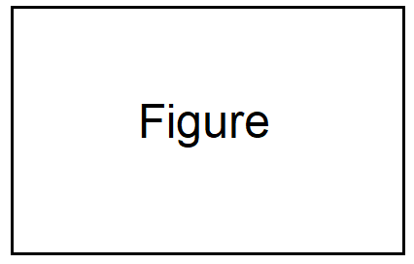
Fig.1 The sample figure.
Acknowledgment
The Author(s) ....
References
[1] Author F.S., Author2 F. (2005) Title of the paper. Int. J. Heat Mass Transfer 44, 230-248.
[2] Author F.. (2000) Book Title. Springer.
[3] Author F.S., Author2 F.S. (2010) Report title. Internal Report Data.
_____________________
* please select your preferences by choosing one of the three options provided. The Organisers will try to accommodate the Author’s choice within the limits of presentation slots available.
All participants are encouraged to submit their poster proposals, however, as in the case of previous meetings, we strongly suggest this form of presentation for PhD students/assistants.
¹⁾ IMPORTANT! The best poster competition is open for works presented by PhD students or research assistants (holding no PhD degree), single-authored or co-authored with supervisors only.

